Portfolio Milestone I

Michael Maye
Colorado State University Global
CSC450: Programming III
Mr. Bari
July 2nd, 2023

Portfolio Milestone I
This submission is an exercise in multi-threading in C++, creating two threads that will concurrently count from zero to twenty, then back down from twenty to zero. To do this, it uses standard threading libraries to create two threads. One for the countUp() function, and one for countDown(). It synchronizes the counting threads to ensure the application outputs are in the correct order. Several potential issues with a system of this nature include deadlocks and race conditions, performance bottlenecks, string manipulation vulnerabilities, and improper exception handling.
Analysis and Observations
Deadlocks and race conditions are always a concern when working with threads. A Deadlock is a condition where two or more threads are waiting for a resource held by the others and will result in the threads endlessly waiting for the other to unlock the resource. Race conditions relate to the timing and scheduling of the actual program. Suppose multiple threads are accessing a shared resource concurrently, and one of the threads modifies the shared resource without being controlled. In that case, this can lead to unexpected outputs or stored variables throughout the runtime of a program. Both Race Conditions and Deadlocks cause unexpected and unwanted behavior in the system. We can avoid these issues by implementing a Mutex into the system, which synchronizes the threads currently running and allows them to work around each other safely, access shared variables, and perform concurrent actions without impacting each other. Another tool to assist with these issues is atomic operations. These operations occur isolated from other threads until they are complete, so there is no interference from threads not currently involved.
The submitted program addresses these issues by using 'std::atomic<int64_t>' to declare the counter variable, which both threads use to increment up to twenty and back down to zero. As both threads have access to the safeAddSubtract() function, there is a possible issue with both threads trying to access this variable simultaneously. With an atomic declaration, only one thread can access it at a time, making it thread-safe and avoiding possible Race Conditions. When the system assigns threads to countUp() and countDown(), there is a possibility of deadlock conditions. If the threads are waiting for their condition variables 'cv_up' and 'cv_down' to allow them to proceed in their respective tasks, and not signaling to each other correctly, they could be waiting indefinitely for these conditions to change. By utilizing a condition variable-based synchronization system, the threads properly notify each other to proceed and avoid any deadlocks.
Strings introduce several issues and vulnerabilities when using multiple threads. If a string is globally declared and accessible by all threads, careful analysis is vital to ensure the string resource is thread-safe, allowing multiple threads to operate without risking unwanted behavior or changes to its value during runtime. There can also be an issue with 'std::cout'. Having multiple threads use output can lead to messy and unintended data entering the output window incorrectly or with the wrong timing.
The submitted program uses the countUp() function and countDown() function to log messages to the output using the string 'std::string logMessages' using concatenation. Improperly utilized, this could lead to a deadlock or race condition if the threads are simultaneously trying to access this string. The submitted program avoids this issue by ensuring the logMessage strings are only ever declared or used within the mutex of the countUp() or the countDown() function.
Performance is also a concern when using multiple threads. Suppose multiple threads try to access the same resource and must wait for other threads to finish. In that case, this can cause a bottleneck in performance and efficiency in a system causing frequent locking and unlocking of mutexes and increasing the computational overhead of the program. Problems can also stem from how the workload is divided between multiple threads. If one thread has significantly less work than the other, it may become idle and wait for the other threads to finish, causing unnecessary CPU underutilization. It is important to pay close attention to the architecture of the threads and the operations they perform. Developers should ensure that each thread pulls the same weight throughout the runtime and minimize the scope and frequency of shared variables. Performance can improve drastically by carefully analyzing the system, managing workloads, optimizing synchronization mechanisms, and minimizing shared resources and scope.

In the submitted program, there are no significant performance issues. While multiple threads are used, and are synchronized with the use of condition variable switching and locks, there is not a significant impact on performance given the computationally light tasks they are performing. Alternatives like lock-free algorithms or atomic variables could be utilized if performance has diminished due to high computational or complexity type tasks, but this program does not require this depth of performance monitoring.

Exception handling is of significant importance when using multiple threads. During runtime, if a thread experiences an error or exception and the system does not handle it properly, the thread could terminate unexpectedly, causing any number of issues by not performing whatever critical task it was brought into the system to perform. However, handling these exceptions can be more complicated than others. With the increased amount of moving parts during runtime, catching and managing exceptions can be difficult.

This program uses 'std::exception_ptr' to capture any exceptions within the threads. It then stores these exceptions in the 'thread_exceptions' array with a size equal to the number of threads running. When both threads have completed their tasks, the main thread checks 'thread_exceptions' for any thrown during runtime. If there are, it then re-throws the exception to handle it properly.
Screen Shot
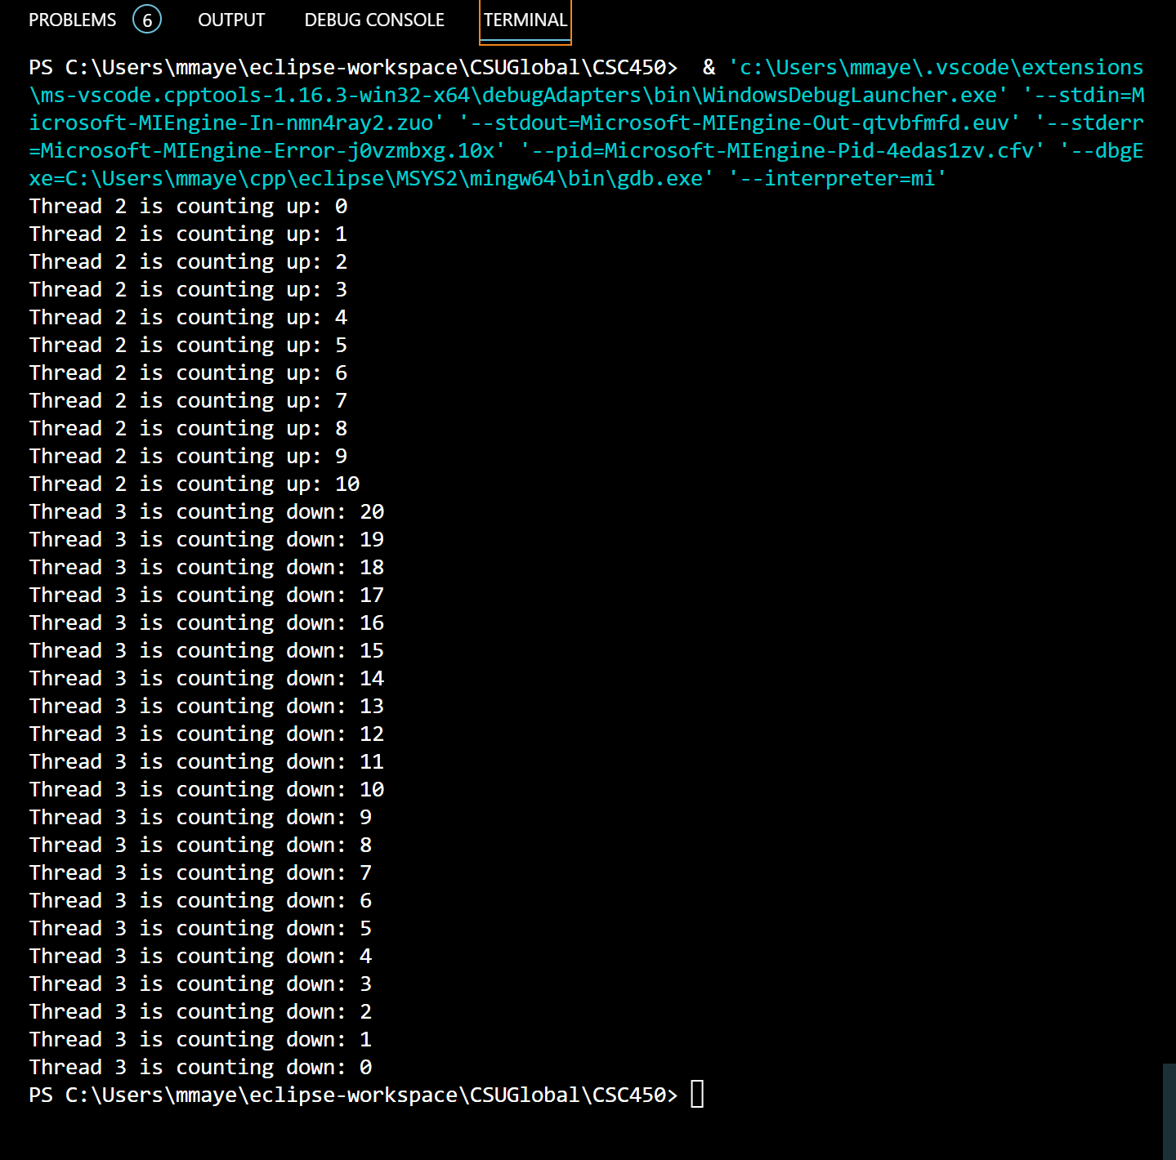
References
Ballman, A. (2016). SEI CERT C++ Coding Standard: Rules for Developing Safe, Reliable, and Secure Systems in C++ (2016 Edition). SEI CERT C++ Coding Standard. https://resources.sei.cmu.edu/forms/secure-coding-cpp-form.cfm
C++11 Standard Library Extensions — Concurrency. Standard C++. (n.d.). https://isocpp.org/wiki/faq/cpp11-library-concurrency
TylerMSFT. (n.d.). C++ Standard Library Overview (STL). C++ Standard Library Overview (STL) | Microsoft Learn. https://learn.microsoft.com/en-us/cpp/standard-library/cpp-standard-library-overview?view=msvc-170

